Harsha Vardhan
2400040454

Ex. No.: 12
Verification of Ohms Law

Aim:

To Verify Ohms Law

PROCEDURE:
- Login to Tinkercad website through your mail ID and choose the circuit option by clicking on new button.

- In the search option find the required components like potentiometer, battery, multimeter, bulb, etc.
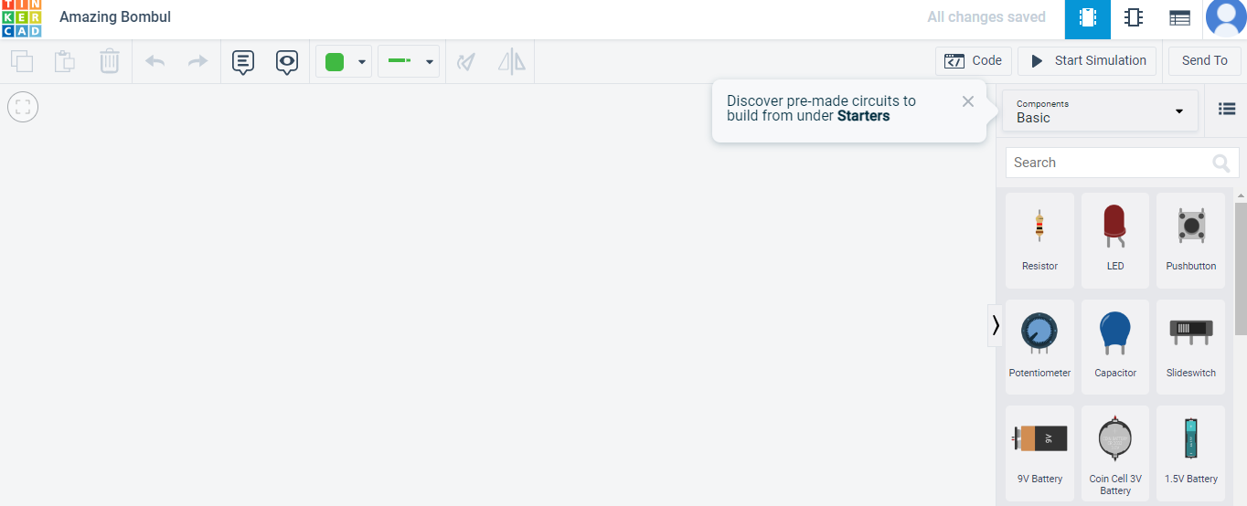
- Create a loop by connecting the battery and bulb with potentiometer and 2 multimeters.
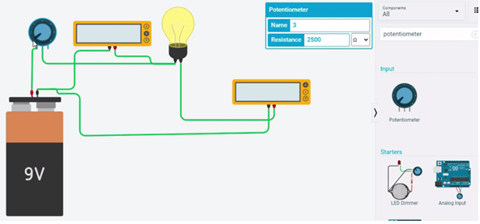

- Fix the resistance of potentiometer as 2500 Ω and record the reading of voltage and current in two multimeters.

- Recordings show that for a fixed resistance, voltage varies directly with the current. This verifies the Ohm’s law i.e. V = I.R.

RESULT:

Thus the basics of ohms law is studied and verified .

OUTPUT SCREENSHOT

